

**F8 - OLINE LEARNING**

**Software Design Specification**

– Hanoi, August 2022 –

**Record of changeS**

| **Date** | **A* M, D** | **In charge** | **Change Description** |
| --- | --- | --- | --- |
| 27/May | A | TriLMHE163206 | Thêm miêu tả Database Schema(I.3.1) |
| 11/Jun | M | DatNTHE161924 | Update Database Schema(I.3.1) |
| 24/Jun | M | DungDTHE163862 | Update Database Schema(I.3.1) |
| 18/Jul | A | DatNTHE161924 | Thêm 3 bảng (I.3.2) (RouteType , RouteTypeItem,RouteTypeAndCourse) |
| 19/Jul | A | Daitvhe161138 | Thêm 3 bảng (I.3.2) (Question, Answer, Correct Answer) |
| 19/Jul | A | Daitvhe161138 | Thêm 1 bảng (I.3.2) (Blog) |
| 22/Jul | A | Daitvhe161138 | Thêm 2 bảng (I.3.2) (CourseAccount, CourseDetails) |
| 22/Jul | A | TriLMHE163206 | Thêm miêu tả Code Package (I.1) |
|  |  |  |  |
|  |  |  |  |
|  |  |  |  |
|  |  |  |  |
|  |  |  |  |

*A - Added M - Modified D - Deleted

**Table of Contents**

I. Overview 4

1. Code Packages 4

3. Database Design 4

3.1 Database Schema 4

3.2 Table Descriptions 5

II. Code Designs 6

1. <Feature Name1> 6

1.1 <Use Case Name> 6

2. <Feature Name2> 7

# I. Overview

## 1. Code Packages

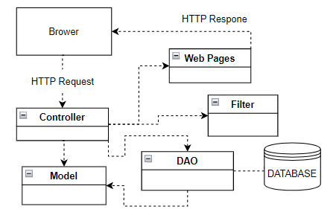

***Package descriptions***

| **No** | **Package** | **Description** |
| --- | --- | --- |
| 01 | Model | Model: Components in a package module can include classes, objects, or other elements to represent the data and logic of the application. Model is a place to process, store and query data, ensure consistency, handle data changes. |
| 02 | DAO | Database Connection: The Packet DAO may contain components for establishing and managing connections to the database. This includes information about configuring connections, handling connection failures, and creating database sessions. |
| 03 | Controller | Components in a package module can contain classes, objects, or other elements that coordinate the interaction between the Model and the View. The Controller is the place to handle events from the user, send requests to the Model to update the data, and navigate the View to display the results. |
| 04 | Web pages | Components in the package module related to the user interface. View represents how data is displayed to the user, be it graphical interfaces, web pages, or any other form in which the user interacts with the application. |
| 05 | Filter | Used to manage filters |

## 3. Database Design

### 3.1 Database Schema

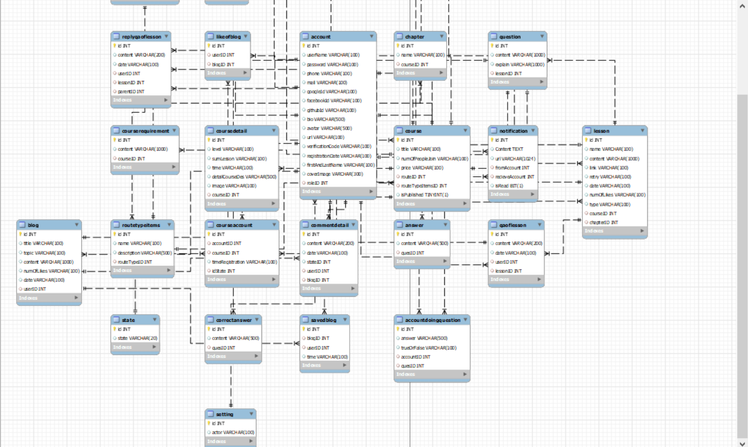

### 3.2 Table Descriptions

#### RouteType

| **No** | **Field name** | **PK?** | **FK?** | **UN?** | **Null?** | **Description** |
| --- | --- | --- | --- | --- | --- | --- |
| *01* | *id* | *X* | *X* |  |  | *id of RouteType* |
| *02* | *name* |  |  |  |  | *Name of RouteType* |
| *03* | *image* |  |  |  |  | *Image of RouteType* |
| *04* | *description1* |  |  |  |  | *Description1 of RouteType* |
| *05* | *description2* |  |  |  |  | *Description2 of RouteType* |
| *06* | *status* |  |  |  |  | *Status of RouteType* |

#### RouteTypeItem

| **No** | **Field name** | **PK?** | **FK?** | **UN?** | **Null?** | **Description** |
| --- | --- | --- | --- | --- | --- | --- |
| *01* | *id* | *X* | *X* |  |  | *id of RouteTypeItem* |
| *02* | *name* |  |  |  |  | *Name of RouteTypeItem* |
| *03* | *description* |  |  |  |  | *Description of RouteTypeItem* |
| *04* | *routeTypeID* |  | *X* |  |  | *id of RouteType* |

#### LikeOfBlog

| **No** | **Field name** | **PK?** | **FK?** | **UN?** | **Null?** | **Description** |
| --- | --- | --- | --- | --- | --- | --- |
| *01* | *id* | *X* | *X* |  |  | *id of* *likeOfBlog* |
| *02* | *userID* |  | *X* |  |  | *id of user* |
| *03* | *BlogID* |  | *X* |  |  | *id of blog* |

#### Setting

| **No** | **Field name** | **PK?** | **FK?** | **UN?** | **Null?** | **Description** |
| --- | --- | --- | --- | --- | --- | --- |
| *01* | *id* | *X* | *X* |  |  | *id of Setting* |
| *02* | *actor* |  | *X* |  |  | *Name of setting* |

#### Status

| **No** | **Field name** | **PK?** | **FK?** | **UN?** | **Null?** | **Description** |
| --- | --- | --- | --- | --- | --- | --- |
| *01* | *id* | *X* | *X* |  |  | *id of status* |
| *02* | *status* |  | *X* |  |  | *Name of status* |

#### CourseRequirement

| **No** | **Field name** | **PK?** | **FK?** | **UN?** | **Null?** | **Description** |
| --- | --- | --- | --- | --- | --- | --- |
| *01* | *id* | *X* | *X* |  |  | *id of CourseRequirement* |
| *02* | *content* |  | *X* |  |  | *content of CourseRequirement* |
| *03* | *courseID* |  | *X* |  |  | *id of sCourse* |

#### Question

| **No** | **Field name** | **PK?** | **FK?** | **UN?** | **Null?** | **Description** |
| --- | --- | --- | --- | --- | --- | --- |
| *01* | *id* | *X* |  |  |  | *id of Question* |
| *02* | *content* |  |  |  |  | *content of Question* |
| *03* | *explain* |  |  |  |  | *explain of Question* |

#### Answer

| **No** | **Field name** | **PK?** | **FK?** | **UN?** | **Null?** | **Description** |
| --- | --- | --- | --- | --- | --- | --- |
| *01* | *id* | *X* |  |  |  | *id of Answer* |
| *02* | *content* |  |  |  |  | *content of Answer* |
| *03* | *questionID* |  | *X* |  |  | *questionID of Answer* |

#### CorrectAnswer

| **No** | **Field name** | **PK?** | **FK?** | **UN?** | **Null?** | **Description** |
| --- | --- | --- | --- | --- | --- | --- |
| *01* | *id* | *X* |  |  |  | *id of CorrectAnswer* |
| *02* | *content* |  |  |  |  | *content of CorrectAnswer* |
| *03* | *questionID* |  | *X* |  |  | *questionID of CorrectAnswer* |

#### Blog

| **No** | **Field name** | **PK?** | **FK?** | **UN?** | **Null?** | **Description** |
| --- | --- | --- | --- | --- | --- | --- |
| *01* | *id* | *X* |  |  |  | *id of Blog* |
| *02* | *title* |  |  |  |  | *title of Blog* |
| *03* | *topic* |  |  |  |  | *topic of Blog* |
| *04* | *content* |  |  |  |  | *content of Blog* |
| *05* | *numOfLikes* |  |  |  |  | *num of Likes of Blog* |
| *06* | *date* |  |  |  |  | *date of Blog* |
| *07* | *userID* |  | *X* |  |  | *userID of Blog* |

#### Course

| **No** | **Field name** | **PK?** | **FK?** | **UN?** | **Null?** | **Description** |
| --- | --- | --- | --- | --- | --- | --- |
| *01* | *id* | *X* |  |  |  | *id of Course* |
| *02* | *title* |  |  |  |  | *title of Course* |
| *03* | *numOf PeopleJoin* |  |  |  |  | *number of people join the course* |
| *04* | *price* |  |  |  |  | *price of Course* |
| *05* | *routeID* |  | *X* |  |  | *route ID of Course(references RouteType(id))* |
| *06* | *routeType ItemsID* |  | *X* |  |  | *route type items ID of Course(refrences RouteTypeItems(id))* |
| *07* | *is published* |  |  |  |  | *determine whether the course is public or not* |

#### Chapter

| **No** | **Field name** | **PK?** | **FK?** | **UN?** | **Null?** | **Description** |
| --- | --- | --- | --- | --- | --- | --- |
| *01* | *id* | *X* |  |  |  | *id of Chapter* |
| *02* | *name* |  |  |  |  | *name of Chapter* |
| *03* | *courseID* |  | *X* |  |  | *courseID of Chapter(references Course(id))* |

#### Lesson

| **No** | **Field name** | **PK?** | **FK?** | **UN?** | **Null?** | **Description** |
| --- | --- | --- | --- | --- | --- | --- |
| *01* | *id* | *X* |  |  |  | *id of Lesson* |
| *02* | *name* |  |  |  |  | *name of Lesson* |
| *03* | *content* |  |  |  |  | *content of Lesson* |
| *04* | *link* |  |  |  |  | *link of Lesson* |
| *05* | *retry* |  |  |  |  | *retry of Lesson* |
| *06* | *date* |  |  |  |  | *date of Lesson* |
| *07* | *numOfLikes* |  |  |  |  | *number of people like the Lesson* |
| *08* | *type* |  |  |  |  | *type of Lesson(video or practice)* |
| *09* | *courseID* |  | *X* |  |  | *courseID of Lesson(references Course(id))* |
| *10* | *chapterID* |  | *X* |  |  | *chapterID of Lesson(references Chapter(id))* |

#### Notification

| **No** | **Field name** | **PK?** | **FK?** | **UN?** | **Null?** | **Description** |
| --- | --- | --- | --- | --- | --- | --- |
| *01* | *id* | *X* |  |  |  | *id of Notification* |
| *02* | *content* |  |  |  |  | *content of Notification* |
| *03* | *url* |  |  |  |  | *url of Notification* |
| *04* | *fromAccount* |  | *X* |  |  | *message from account(references account(id))* |
| *05* | *recieveAccount* |  | *X* |  |  | *message to account(references account(id))* |
| *06* | *isRead* |  |  |  |  | *notification is read or not* |

#### QAOfLesson

| **No** | **Field name** | **PK?** | **FK?** | **UN?** | **Null?** | **Description** |
| --- | --- | --- | --- | --- | --- | --- |
| *01* | *id* | *X* |  |  |  | *id of QA* |
| *02* | *content* |  |  |  |  | *content of QA* |
| *03* | *date* |  |  |  |  | *date of QA* |
| *04* | *userID* |  | *X* |  |  | *userID of QA(references Account(id))* |
| *05* | *lessonID* |  | *X* |  |  | *lessonID of QA(references Lesson(id))* |

#### ReplyQAOfLesson

| **No** | **Field name** | **PK?** | **FK?** | **UN?** | **Null?** | **Description** |
| --- | --- | --- | --- | --- | --- | --- |
| *01* | *id* | *X* |  |  |  | *id of replyQA* |
| *02* | *content* |  |  |  |  | *content of replyQA* |
| *03* | *date* |  |  |  |  | *date of replyQA* |
| *04* | *userID* |  | *X* |  |  | *userID of replyQA(references Account(id))* |
| *05* | *lessonID* |  | *X* |  |  | *lessonID of replyQA(references Lesson(id))* |
| *06* | *parentID* |  | *X* |  |  | *parentID of replyQA(references QAOfLesson(id))* |

#### CourseAccount

| **No** | **Field name** | **PK?** | **FK?** | **UN?** | **Null?** | **Description** |
| --- | --- | --- | --- | --- | --- | --- |
| *01* | *id* | *X* |  |  |  | *id of CourseAccount* |
| *02* | *accountID* |  | *X* |  |  | *accountID of CourseAccount(references Account(id))* |
| *03* | *courseID* |  | *X* |  |  | *courseID of CourseAccount(references Course(id))* |
| *04* | *timeRegistration* |  |  |  |  | *timeRegistration of CourseAccount* |
| *05* | *isState* |  |  |  |  | *State of CourseAccount* |

#### CourseDetail

| **No** | **Field name** | **PK?** | **FK?** | **UN?** | **Null?** | **Description** |
| --- | --- | --- | --- | --- | --- | --- |
| *01* | *id* | *X* |  |  |  | *id of CourseDetail* |
| *02* | *level* |  |  |  |  | *level of CourseDetail* |
| *03* | *sumofLesson* |  |  |  |  | *Sum Lessons of CourseDetail* |
| *04* | *detailCourseDes* |  |  |  |  | *description of CourseDetail* |
| *05* | *image* |  |  |  |  | *image of CourseDetail* |
| *06* | *courseID* |  | *X* |  |  | *courseID of CourseDetail(references Course(id)* |

# 

# II. Code Designs

## 1. <*Doing Question*>

### 1.1 <Doing Question>

*The "Doing Question" screen typically refers to a user interface or display that allows individuals to interact with and answer questions. The specific design and layout of the screen may vary depending on the application or platform it is used in, but here is a general description*

#### a. Class Diagram

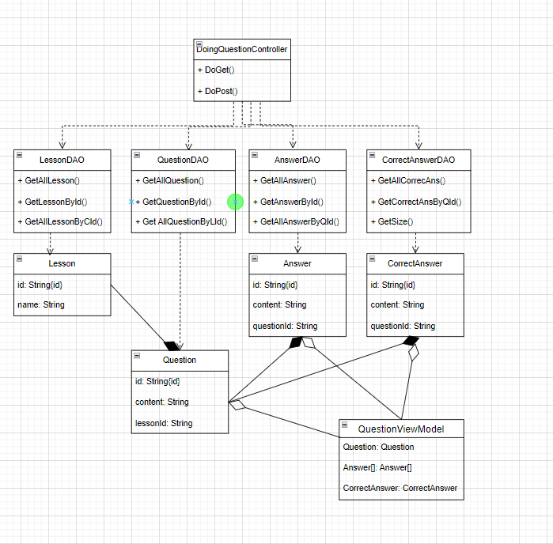

#### b. Sequence Diagram(s)

#### c. Database Queries

**1.checkQuestionIsAnsweredByAccount(String accountID, String questionID)**

*select * from AccountDoingQuestion where accountID = "+accountID+" and quesID = "+questionID”*

**2.insertAccountDoingQuestion(String answer, String trueOrFalse, String accountID, String questionID)**

*insert into AccountDoingQuestion(id, answer, trueOrFalse, accountID, quesID) Values(?, ?, ?, ?, ?)"*

**3.getAllAnswerByQuesID(String quesID)**

select * from Answer where quesID =;

**4.getCorrectAnswerByQuesID(String quesID)**

select * from CorrectAnswer where quesID =;

**5.getAccountDoingQuestionByAccountIDAndQuesID(String accountID, String quesID)**

select * from AccountDoingQuestion where accountID = and quesID =